In your private capacity.
Lieschen-Hermine Birkenbaum.
[President],
Regional mock service,
Unsinngasse 36,
3011 Berne,
Switzerland Nation.

25 April 2024

FOR YOUR INFORMATION

In your private and public capacity.

1. In congruence with you, Lieschen-Hermine Birkenbaum, we hope that this letter will find you in good physical and mental health.

2. You have harassed us several times resulting in a penalty, in your case a fine.
Therefore I / we have sent you an invoice. To this date the invoice has not been paid.
2.1 You have violated various Notices stated in the Judicial Notices JS029587168GB
and Global Constitution documents I/we have sent you.
2.2 Despite all, the harassment on your part continues resulting in an arrest-warrant.

3. Enclosed is the arrest-warrant issued in your name, Lieschen-Hermine Birkenbaum.
3.1 This warrant is published on the websites of www.wethepeople-schweiz.ch and
www.wethepeople-switzerland.ch.

4. Further information, including lots of documentation for your further education
can be found on the above-mentioned websites.

5. Quote from Pascal Najadi, 07 May 2024:

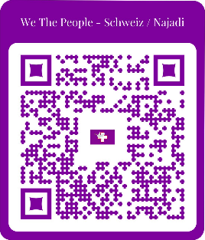
“God is in your body and stands with you,
all the way and beyond duty call, Always.
And Trust yourself and the Military,
we protect all divine Human Species and God is in charge,
worldwide and beyond our divine Earth.
We fully control and command the Swiss Military in the Swiss Territory and all other Territories on our divine Earth.”

Greetings, PLACE AUTOGRAPH + FINGER PRINT here, write in red or blue, not BLACK !
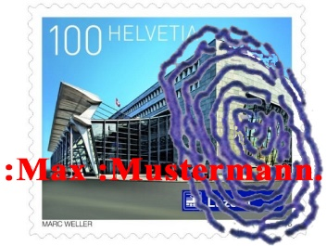

By the power vested in me/us by the Almighty Creator and the love of all Creation.
Entering facts into the fiction world.
And so it is.

